NAME : C Rishitha

REGISTER NUMBER : 192111084

COURSE CODE : CSA0520

COURSE NAME : DATABASE MANAGEMENT FOR DATA ANALYTICS

##### Questions:

1. List the departments where the faculty members are working.
2. Find the student who has no score in any of the courses. List student name and course number.
3. The office clerk needs the names of the courses taken by the faculty belonging to ‘ECE department’ whose name is ‘Kamal’

OUTPUTS:

1)

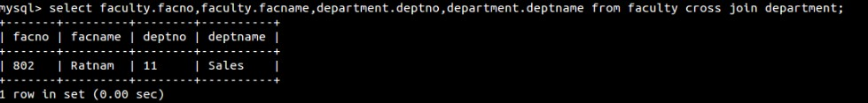

2)

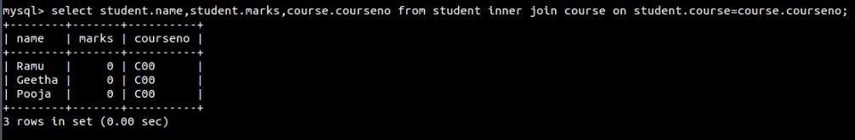

3)

